**Exercise 2:** Create a shortcut for the folder “family” from “Exercise 2” using all the methods you know.

-- *Done while Sergio was explaining it → Corrected*

First we need to add a network location (Right-click on “This PC” and “Add a network location”)

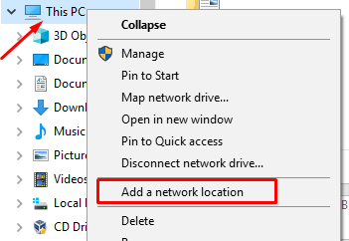

Then we click “Choose a custom network location” and then put the shared folder path:

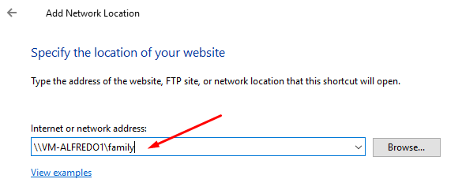

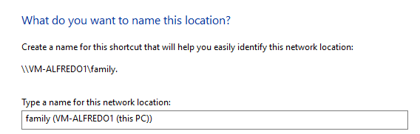

After this we will finish the process and, alternatively, we will do like we did in Exercise 2: we will go to “Map Network Device”

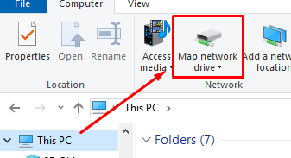

We have to put the shared folder’s path and check “Reconnect at sign-in”

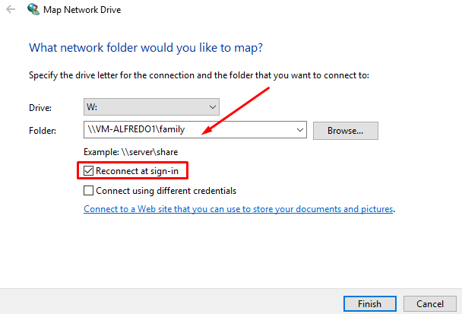

Finally, this will be the result:

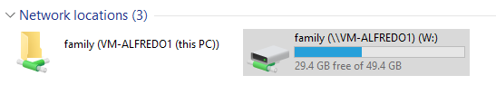

**ALFREDO PUERTA GALLEGO DW1E**